MMA3001 Airfoil Self-Noise Prediction Report
1. Engineering problem
This project aims to predict the self-noise of various NACA 0012 airfoil sizes in scaled-sound-pressure (dB) at a target frequency of the frequency spectrum measured under different wind tunnel speed, angle of attack and suction side displacement thickness by using neural network regression. This problem is useful to design quieter blades for aircraft while still maintaining aerodynamic efficiency and the computational result can be useful as a tool to determine an accurate prediction.
This report compares the performance of neural network regression (with and without data normalization) against two simpler methods, mean baseline and linear regression. Methods are ranked by prediction accuracy, with computational cost as a secondary criterion for the final selection.
2. Inputs and outputs
Scope of inputs and outputs
The airfoil self-noise data used for this project is donated from NASA to UCI Machine Learning Repository [1]. The regression model takes in five numeric inputs and returns one numeric output, which includes the specific target frequency, angle of attack, chord length, free-stream velocity and suction side displacement thickness, which their units and labelling used in the code are presented in the following table:
Table 2.1 Model inputs information
Elements | Unit | Labels
Target frequency | Hz | Frequency_Hz
Angle of attack | deg ($°$) | Angle_of_attack_deg
Chord length | m | Chord_length_m
Free-stream velocity | m/s | Free_stream_velocity_m/s
Suction side-displacement thickness | m | Suction_side_displacement_thickness_m
The output of the analysis is the scaled sound pressure level, where its unit and labelling used in the code are presented in the following table:
Table 2.2 Model output information
Elements | Unit | Labels
Scaled sound pressure level_ | dB | Scaled_sound_pressure_level_dB
Data preprocessing
Before data fitting and analysis, five checks were run to ensure data validity.
- Row counts: Use .shape to check dimension of input and output entries. Both entries should have identical sample count with input of 5 dimensions and output of 1 dimension.
- Data type: Use df.dtypes to check that every column is numeric. All columns should be numeric.
- Missing values: Use df.isnull().sum() to count empty cells in every column. The value should be zero.
- Duplicated values: Use df.duplicated().sum() to count repeated rows. The value should be zero.
- Valid ranges: Use df.describe() to confirm the following criteria:
  - Minimum frequency 0 Hz
  - Minimum chord length ≥ 0 m
  - Minimum of free stream velocity ≥ 0 m/s
  - Minimum of suction side displacement thickness ≥ 0 m
  - Minimum of scaled sound pressure level ≥ 0 dB
* Note that df.describe() returns the overall statistics (e.g. mean, standard deviation, etc.), the properties investigate is only the “count” and “min” properties.
If a sample (row) fails a check, the data should be reported and excluded prior to analysis. In the provided data set, the input shape is (1503, 5) and the output shape is (1503,). All data passes the preprocessing check.
By observing data, rows from the same airfoil setup (same angle of attack, chord length, free stream velocity and suction side displacement thickness) are strongly related, so they cannot be assumed to be independent of each other. Hence, data should be split according to the identity defined by the four properties of the airfoil setup with details stated in Section 4.
3. Computational solution
Overview of resultant approach
Neural network regression with scaled MLP pipeline with data normalization and a multi-layer perceptron (MLP) regressor with a hidden layer width of 50 (count of neurons) is an optimal choice.
make_pipeline(StandardScaler(), make_mlp(hidden_layer_sizes=(50,)))
Code 3.1 Neural network regression pipeline
def make_mlp(random_state=42, hidden_layer_sizes=(50,), alpha=0.001,
early_stopping=True):
return MLPRegressor(
hidden_layer_sizes=hidden_layer_sizes,
activation="relu",
solver="adam",
alpha=alpha,
learning_rate_init=0.01,
max_iter=2500,
early_stopping=early_stopping,
validation_fraction=0.15,
n_iter_no_change=35,
tol=1e-5,
random_state=random_state,
)
Code 3.2 MLP regressor architecture
The normalization step rescales data to a mean of 0 with standard deviation of 1 to ensure no input dominates due to numerical value but also preserves the behavior of data. The regressor then features a single hidden layer with a width of 50 and a ReLU activation function to allow a combination of linear and non-linear operation. The weight of each neuron is then iteratively updated using Adam optimizer with L2 penalty to discourage very large weights. To save time, set aside random 15% of the rows and stop training if error does not improve for 35 rounds.
This method is selected in three steps. Firstly, compare four alternative methods on one data split in Section 4 and use a width of 20 as a starting value for both neural network pipelines. Secondly, check results with 10-fold group cross-validation in Section 5. Thirdly, tune the hidden layer width for improved performance in Section 6 with other settings unchanged. The first two steps mainly use Mean Absolute Error (MAE) (dB), Root Mean Square Error (RMSE) (dB), coefficient of determination (R²) as indicator, while step 3 uses mainly RMSE, R² and comparison with linear regression.
Limitations
The optimal method is the best method among the four proposed methods rather than global as other non-linear and potentially flexible methods like decision tree regression and support vector regression is not studied in this report. Besides that, the model is trained solely from one airfoil shape (NACA 0012), and hence evaluated model should not be applied for other airfoils for justifiable evaluation. Lastly, extrapolation where prediction made for data outside the training range should be flagged as model covers within the training range.
4. Alternative solutions
To predict scaled sound pressure level, regression methods are appropriate as the purpose of regression is to form prediction of given inputs through fitting. Among the variety of choices of regression methods, neural network regression is assumed as the most optimal choice as it is highly flexible to determine the relationship of complex features.
This section tests the assumption by comparing four candidates on one data split:
- Mean baseline
- Linear regression
- Neural network regression with unscaled MLP pipeline (without normalization)
- Neural network regression with scaled MLP pipeline (with normalization)
Comparison procedure
This section states the procedure to utilize neural network regression after the data cleaning procedure from Section 2:
- Data splitting:
  - Group split the data by angle of attack, chord length, free-stream velocity, suction side displacement thickness using GroupShuffleSplit().
  - Obtain train, validation and test set with a ratio of 60:20:20.
- Data fitting:
Fit training set into the following models to obtain required parameter(s).
  - Mean baseline: Calculate the mean of the training data.
  - Linear regression: Use LinearRegression().fit(X, y)
  - Neural network regression with unscaled MLP pipeline: Use make_mlp.fit(X,y)
  - Neural network regression with scaled MLP pipeline: Use make_pipeline(StandardScaler(), make_mlp()).fit(X,y)
- Data prediction:
Substitute train and validation data into the parameters obtained from Step 2 for all four methods.
- Data analysis
For all four methods:
  - Obtain the validation metrics (MAE, RMSE and R²) by comparing the prediction and actual value of the train and validation data set.
  - Method selection according to lowest MAE and RMSE score and analysis of R² score.
Data analysis
The figures below show the MAE, RMSE and of the four methods:
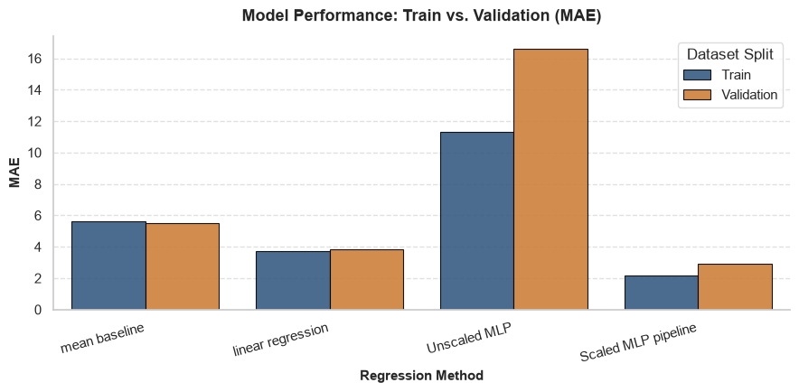
Figure 4.1 Training and validation data MAE comparison
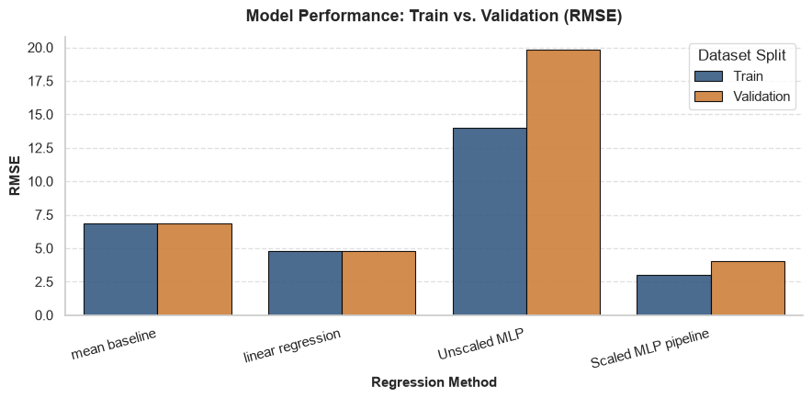
Figure 4.2 Training and validation data RMSE comparison
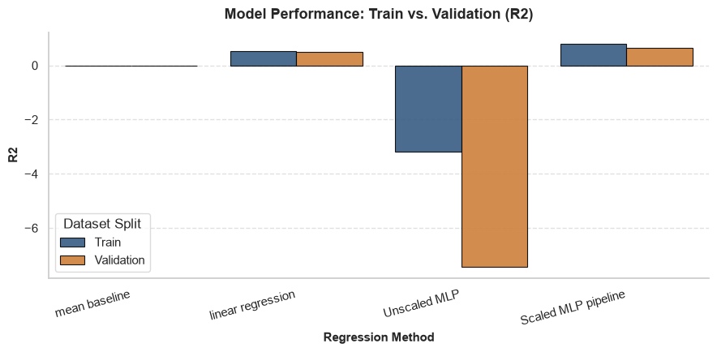
Figure 4.3 Training and validation data R² comparison
As discerned from the three graphs, juxtaposition of training and validation set results show overfitting across models as each method’s model generally performs better on training data. Aside from that, neural network regression with unscaled MLP pipeline possesses significantly highest error as it has highest MAE and RMSE score and performs worse than the mean due to negative R² value. Hence, this method is eliminated in further detailed analysis as scaling input is essential.
For the remaining three methods, the values of each metric are relatively similar. For a clearer view of the results, the table shows the value of the validation metrics of the three methods.
Table 4.1 Training and validation metrics for mean baseline, linear regression and neural network regression with scaled MLP pipeline
Model | Mean baseline |  | Linear regression |  | Neural network regression with scaled MLP pipeline
Dataset | Training | Validation | Training | Validation | Training | Validation
MAE | 5.61 | 5.52 | 3.74 | 3.82 | 2.18 | 2.90
RMSE | 6.84 | 6.83 | 4.77 | 4.82 | 2.98 | 4.04
R² | 0 | 0 | 0.51 | 0.50 | 0.81 | 0.65
From the table, the result shows that neural network regression with scaled MLP pipeline is a potentially optimal choice because the MAE and RMSE on the validation data set is the lowest and R² highest among the remaining three computational methods.
Benefits and limitations of methods
Mean baseline is simplest and most robust as it directly fits the output and training input mean, thus it sets the minimum level any model must beat. Linear regression is generally simpler and highly interpretable because the influence of input on output can be easily discerned by observing, for example, the coefficients (slope) and further justified in physics. However, it constrains freedom of fitness by limiting it to only lines or planes, where if no proper feature engineering is done, result can be hard or odd to interpret due to unmatched trends. On the other hand, neural networks allow a more complex and curved fitting. This method has high adaptability because models are obtained by a customized and case specific study from the provided dataset. The drawback of it is potentially higher cost and longer runtime as it can require more parameters and arithmetic operations (FLOPs) to operate than linear regression. The physical behaviors between input to output data are less interpretable as model is fitted by utilizing a predefined number of “neurons” with no direct physical meaning.
5. Validation
A single split in Section 4 can be highly coincidental; this section further evaluates if each method’s performance hold across different independent tests. This section utilizes Group K-fold Cross Validation with K=10 using the combined training and validation data set split (80% of whole data) obtained at Section 2, step 1 of “Comparison procedure”. This method is chosen as a consistency evaluation method because it allows repeated and independent testing on data that is split using identities defined by airfoil sizes properties without requiring additional dataset. This method provides a convenient and cheap way for a robust estimation of each model’s generalization ability. The following are detailed steps of conducting Group 10-fold Cross Validation [2]:
- Divide the established combined dataset into K (10) subsets of equal size (folds), keeping each group within the same fold.
- Fit each method on K-1 (9) folds.
- Predict and determine MAE, RMSE and R² for the remaining fold.
- Iterate step 1 to 3 for K times until all fold is being used as the testing fold exactly once
- Average the value of metrics over all 10 iterations.
This section uses a hidden layer width of 20 which allows deeper comparison after Section 3.
Validation analysis
The following graph portrays the MAE, RMSE and R² of each method at each validation fold.
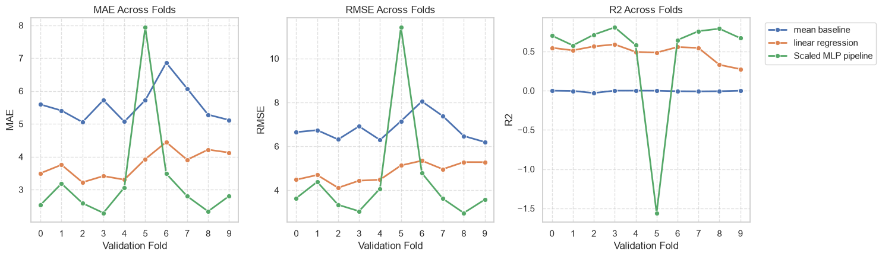
Figure 5.1 Validation metrics tracked at each fold
Observing from the graph, the overall trend suggests that neural network regression with scaled MLP pipeline renders lowest error (lowest MAE and RMSE score) and highest ability to explain the variability of data (highest R²) over most of the folds. However, all three plots show this method performs the worst at fold 5 with highest MAE and RMSE score, and a negative R² score.
To further evaluate overall performance, plot the average scores for each metric over 10 folds.
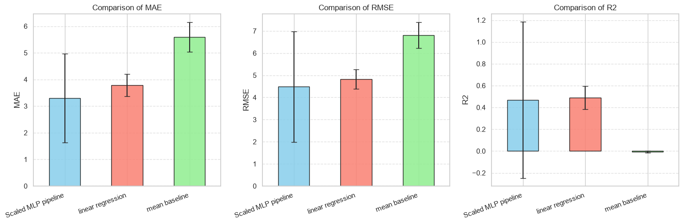
Figure 5.2 Validation metrics of each method with standard deviation
Observing from the graph, the overall trend suggests that neural network regression with scaled MLP pipeline renders lowest mean error (lowest mean MAE and RMSE score) and relatively equal ability to outperform mean baseline with linear regression (similar mean R²). This figure also shows that neural network regression possesses highest standard deviation for MAE and RMSE, which is susceptible due to the worst performance at fold 5. One likely reason is that the setups in fold 5 trains on rare setup which MLP learns less reliable model. The standard deviation of for neural network regression is treated as unexplainable as the value exceeds 1.
As the criteria of model selection is of accuracy, neural network regression with scaled MLP pipeline is an optimal choice among the four proposed methods due to its consistent lowest error scores across multiple validation. However, this cross-validation metric has a limitation where it does not show how well the model predicts other airfoil shapes or wind tunnel setups because data is constrained with no other fresh data and more variety of input is encompassed into training. In case of potentially sample sizes and/or heterogenous sample, partitioning data can lead to high variance and unstable performance across folds that can further drift the true behavior of data.
6. Optimization and performance
According to the above analysis, neural network regression with scaled MLP pipeline is found to be the most optimal choice of four. To enhance the method’s performance, a simple optimization is performed by only changing the hyperparameter related to the count of neurons of the single hidden layer, hidden layer width to improve the performance further. The optimization is tracked and compared with linear regression as baseline reference.
Below states the procedure of optimization:
- Create an array that includes the hyperparameters that signify different counts of neurons to be experimented.
- For each width, run the same Group 10-fold Cross Validation as in Section 5.
- In every fold, record the train and validation RMSE, validation R² and if the MLP beats linear regression in a fold (a “win”).
- Average the validation metrics according to hyperparameters as an indicator to resemble the overall performance for different widths.
Optimization analysis
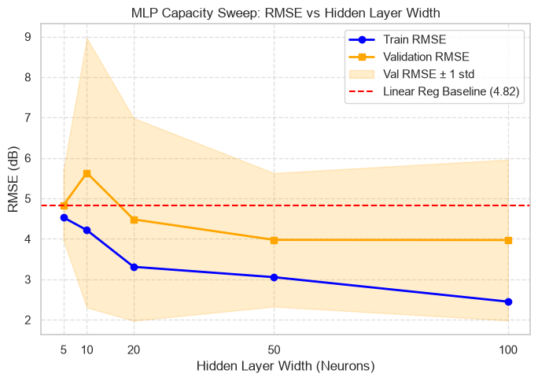
Figure 6.1 Train and validation RMSE of different hidden layer width with standard deviation
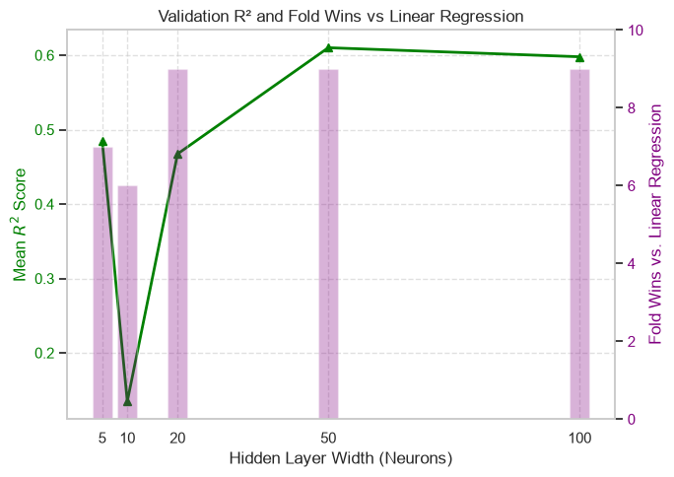
Figure 6.2 R² and “wins” of different hidden layer width
Observing from Figure 6.1, a hidden layer width of possibly 50 and 100 gives the minimum mean RMSE values for the validation set, while width of 100 gives the minimum mean RMSE value for training set. This explains that width of 100 possibly starts to render a more obvious overfit than width of 50. Besides that, a width of 50 renders the lowest upper bound and smallest interval after accounting for its standard deviation, justifies its high stability for with respect to its mean score.
Observing from Figure 6.2, widths 20, 50, 100 beats linear regression in 9 folds, while widths 50 and 100 renders similar score for R². This narrows down the optimal choice of width is between 50 and 100.
Since the performance of width 50 and 100 comes close, cheaper models are preferred. FLOPs (Floating-Point Operations), defined by arithmetic operations including addition, subtraction, multiplication and division is a suitable indicator [3]. Width 50 has 351 weights and 651 FLOPs; width 100 has 701 weights and 1300 FLOPs. Therefore, width 50 is the most optimal choice.
Validation of optimization
For a final evaluation of the optimized model, the model of three methods (mean baseline, linear regression, neural network regression with scaled MLP pipeline) were refitted on the combined training and validation data (80%) and evaluated once on the untouched test set.
Table 6.1 Test-set validation metrics’ value
Metric | Mean baseline | Linear regression | Neural network regression with scaled MLP pipeline
MAE | 5.68 | 3.69 | 3.04
RMSE | 7.15 | 4.98 | 3.96
R² | -0.05 | 0.49 | 0.68
As a result, MAE and RMSE remains the lowest utilizing neural network regression with scaled MLP pipeline which is many% less than mean baseline, many5 less than linear regression. This neural network regression increases R² by many% compared to mean baseline and many% compared to linear regression.
Table 6.2 Test-set cost
Model | Parameter count | FLOPs/prediction | Training time | Prediction time
Mean baseline | 0 | 0 | 205 μs ± 2.69 μs | 12.5 μs ± 118 ns
Linear regression | 6 | 11 | 1.4 ms ± 17.5 μs | 388 μs ± 14.5 μs
Neural network regression with scaled MLP pipeline | 351 | 600 | 905 ms ± 20.1 ms | 799 μs ± 6.22 μs
As a result, the time required for solely prediction for neural network regression with scaled MLP pipeline is the longest which requires 799 μs, which is 64x more than mean baseline and 2x more than linear regression. With higher count of parameters and operations, the time required increases. This pattern applies to training runtime, where the time required is higher, with neural network regression being significantly high (about 650x than linear regression).
7. AI use and reflection
I used Google Gemini for coding only: the plotting code and the Group K-fold code for a more efficient and quality work rendered. I used Claude to organise and document the analysis notebook, to review the report for flow, logic and wording against the project brief, and to explain concepts such as early stopping, validation versus test sets, and FLOPs, which to ensure smooth reading and prevent structural flaws.
I accept outputs after checking them. I conducted research by searching concept definition on various site to validate if explanations or code logic generated by AI remain true. Besides that, I go through the lines of code and report revamp suggestions to ensure I fully understood it before accepting it for my documentation or even make amendments to allow better fit.
The plan stayed mine: choosing the four methods, using group splitting, adopting 10-fold group cross-validation, selecting width 50 for lower cost, and keeping the test set for a single final check. A limitation on AI I found when consulting regarding plan structure is AI tended to agree with my plan rather than challenge it. For example, my first idea of repeating the experiment with different random seeds was not flagged as risky because it can put near-identical rows in both training and validation. I found this issue myself from the lecture notes and switched to group K-fold.
Checking each suggestion made me understand the workflow and its limits, so I can explain and defend every step in the presentation and interview without AI.
8. References
[1] T. Brooks, D. Pope, and M. Marcolini. "Airfoil Self-Noise," UCI Machine Learning Repository, 1989. [Online]. Available: https://doi.org/10.24432/C5VW2C.
[2] GeeksforGeeks. “K- Fold Cross Validation in Machine Learning,”. 2025. [Online]. Available: https://www.geeksforgeeks.org/machine-learning/k-fold-cross-validation-in-machine-learning/
[2] GeeksforGeeks. “Floating-Point Operations Per Second (FLOPS),”. 2025. [Online]. Available: https://www.geeksforgeeks.org/computer-organization-architecture/what-is-floating-point-operations-per-second-flops/

